Section A: Smooth Shading
Section B:
Multi Stroke
Total
Note: This mark is included in the CA1
19
50
31
CHANGKAT CHANGI SECONDARY SCHOOL
ART & DESIGN
TERM 2 WEEK 3 - 4
COLOUR PENCIL SHADING

NAME:____________________________ (___) CLASS:________ DATE:__________

Section A: Smooth shading (19 marks)
Use colour pencils to fill in the spaces provided below.

1) Understanding: What is the purpose of smooth shading in Visual Arts? (2m)

2) Identifying: Which type of the shading below is smooth shading? Tick the correct answer (1m)

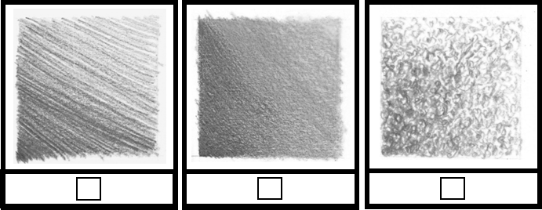

!NOTE
- For every one colour, there must be three tonal values. This means, you must use 3 colour pencils.
For example, if you choose to colour Blue, you must pick out 3 colour pencils that are light blue, medium blue and dark blue.

3) Application: Using one colour, shade the area below and show three tonal values using the smooth shading technique. (2m)

4) Application: Using two complementary colours, shade the area below and show three tonal values per colour using the smooth shading technique. (2m)

5) Application: Using a set of family colours, shade the area below and show three tonal values per colour using the smooth shading technique. (2m)

6) Application: Study the example given below. Using a set of family colours, shade the template given. (10m)
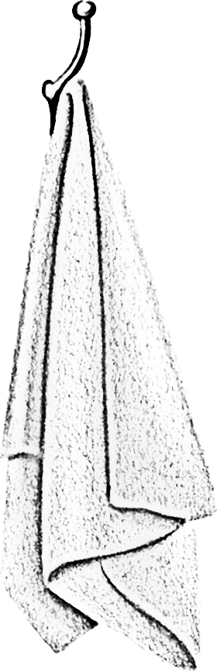
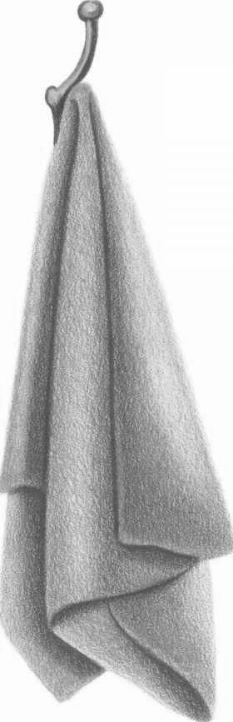

Clarity of tonal values | /5
Correct colours used | /5

Section B: Multidirectional Strokes (31 marks)
Use colour pencils to fill in the spaces provided below.

7) Understanding: What is the purpose of using multidirectional strokes in Visual Arts? (1m)

8) Understanding & Application: Fill in the following table. (10m)

Type of strokes | Purpose  Why do we use these types of strokes? | Example  How do artists use these types of strokes in an artwork? | Application  I. Follow the example given  II. Use a set of 3 family colours  III. Shade in the space below
(1m) | (2m) | 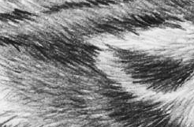
 |  |  | Correct colours: /1 | Clarity of tonal values: /1
(1m) | (2m) | 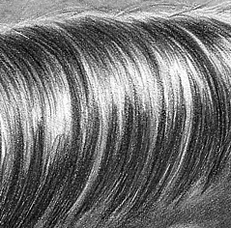
 |  |  | Correct colours: /1 | Clarity of tonal values: /1

!NOTE
- Multidirectional strokes can consist of straight and curved lines.

9) Application: Study the example given below. Using a set of family colours, shade the template given. (10m)
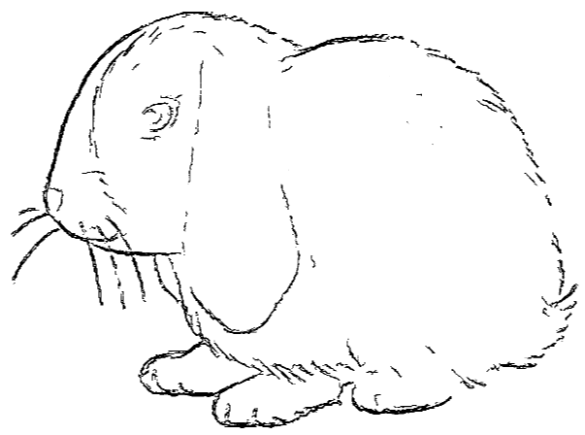
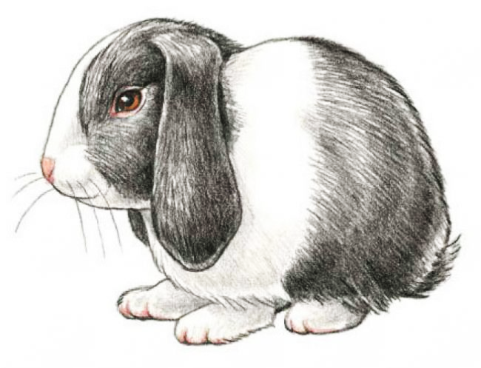
Clarity of tonal values | /5
Correct colours used | /5

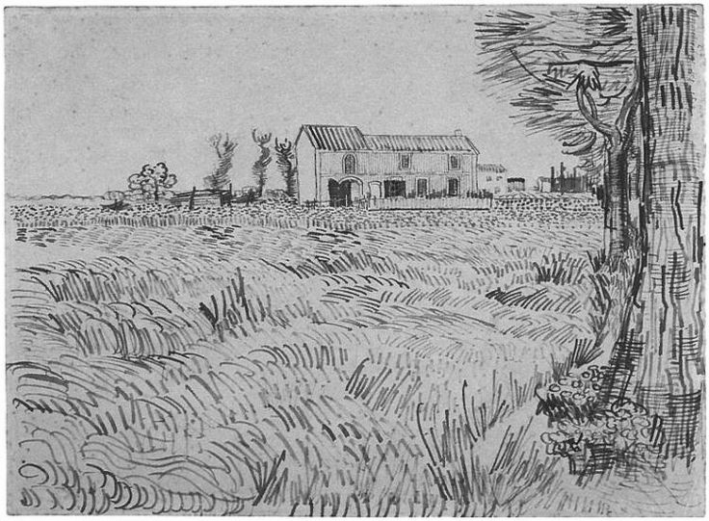
This is an example of a drawing done using multidirectional strokes, which creates the texture of the grass and tree bark.

Artist: Vincent Van Gogh
Title: Farmhouse with Wheat Field along a Road

Source:https://s-media-cache-ak0.pinimg.com/736x/65/27/66/652766bd7491e2a92c926305af30f9d3.jpg
10) Application: Name the title of the artwork below and completely colour the template given using multidirectional strokes based on the example provided by your teacher. (10m)
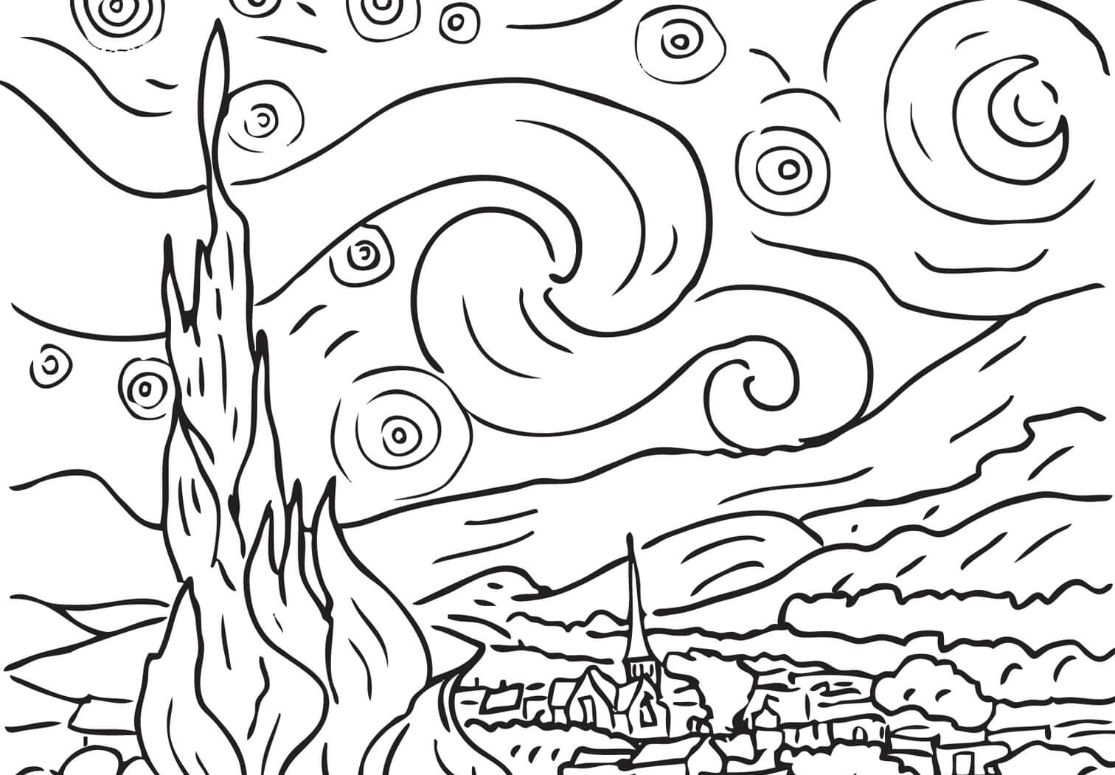
Clarity of tonal values | /3
Correct colours used | /4
Artwork title | /1
Variety of strokes used | /2

Name of Artist: Vincent Van Gogh
Title of Artwork: ________________________________________
Year: 1889

- End -

