Section A: Theory & Practical
Section B:
Artist R
Total
Note: This mark is included in the CA1
50
32
18
CHANGKAT CHANGI SECONDARY SCHOOL
ART & DESIGN
TERM 1 WEEK 1 - 2
COLOUR THEORY

NAME:____________________________ (___) CLASS:________ DATE:__________

Section A: Colour Theory & Practical (32 marks)
Read the questions carefully. Fill in the answers in the spaces provided below.

1) Understanding: What is the purpose of Colour Theory in Visual Arts? (2m)

2) Identifying: Name the diagram [Di. 1] below: (1m)

[Di. 1]

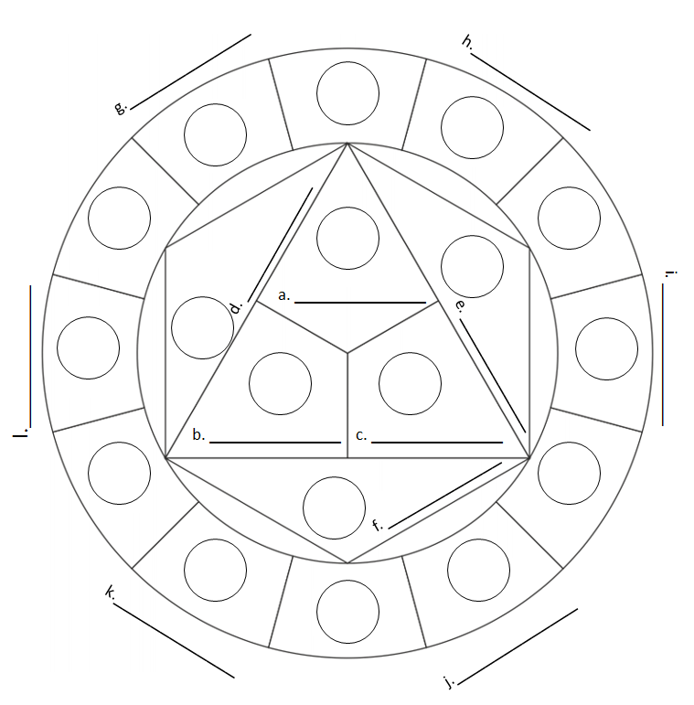

3) Identifying and Applying: Using the diagram [Di. 1] above, write down (12 marks)
- Write down the names of the colours
- Write down the categories (Primary colour, Secondary colour, Tertiary colour)
- Using colour pencils, fill in the circles with the corresponding colours.

!NOTE
- Primary Colours are the first colours and no other colours can make these.
- Primary + Primary = Secondary
- Primary + Secondary = Tertiary

4) Identifying and Applying: Using the diagram [Di. 1] above, dissect and write down the two colour temperatures. (2m)

5) Understanding: What are complementary colours? (1m)

6) Identifying and Applying: Using colour pencils, fill in the areas below with complementary colours. Write down the names of the colours chosen. (4m)

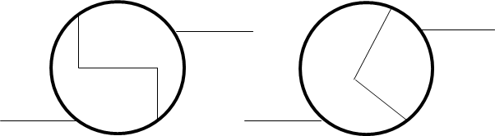

7) Understanding: What are family colours? (1m)

8) Identifying and Applying: Using colour pencils, fill in the areas below with sets of family colours. Write down the names of the colours chosen. (9m)

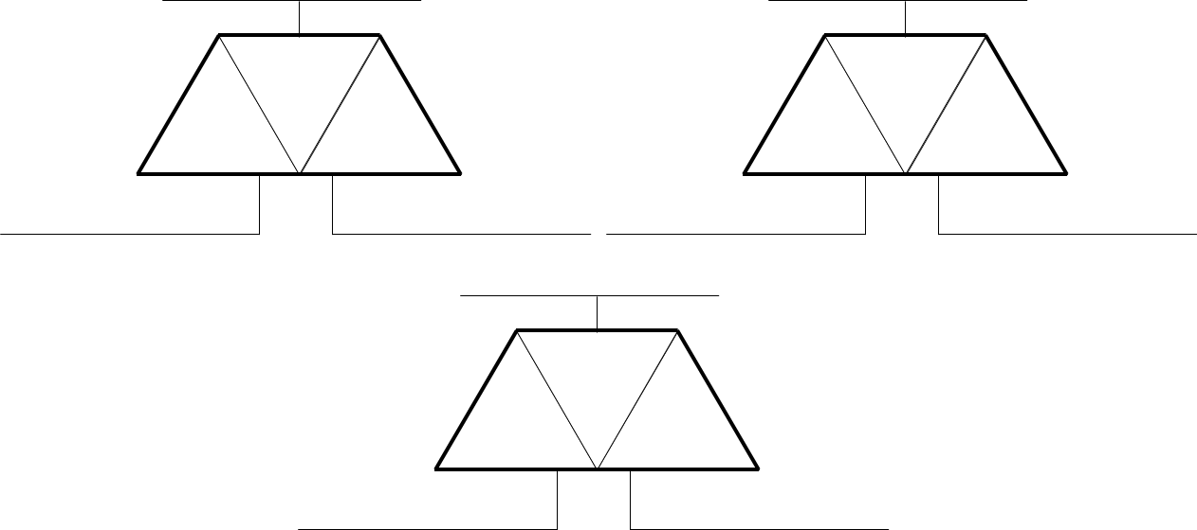

Section B: Artist Reference (18 marks)
Read the questions carefully. Fill in the answers in the spaces provided below. Use colour pencils for the artworks.

9) Artist Reference: Name the artist who painted the artwork below and fill in the correct spaces with the specific colours of the artwork. Identify the type of colours used in this artwork.
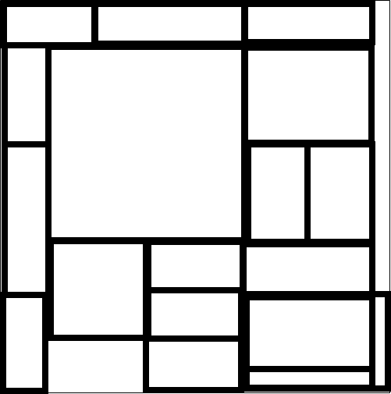

Name of Artist: __________________________________
Title of Artwork: Composition en rouge, jaune, bleu et noir
Year: 1926
Type of colours used:______________________________
_______________________________________________

Neatness in colouring | /1
Correct colours used | /2
Name of Artist | /1
Type of colours used | /1

8) Artist Reference: Name the title of the artwork below and fill in the correct spaces with the specific colours of the artwork. Identify the type of colours used in this artwork.
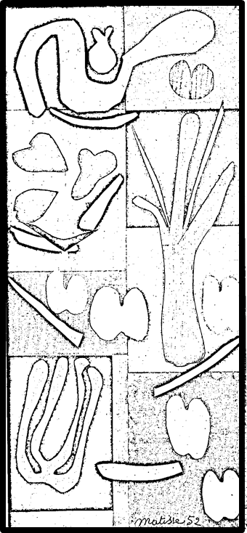

Name of Artist: Henri Matisse
Title of Artwork: ________________________________________
Year: 1952
Type of colours used:_____________________________________
_______________________________________________________

Neatness in colouring | /1
Correct colours used | /4
Name of Artist | /1
Type of colours used | /1

8) Artist Reference: Name the title of the artwork below and fill in the correct spaces with the specific colours of the artwork. Identify the type of colours used in this artwork.
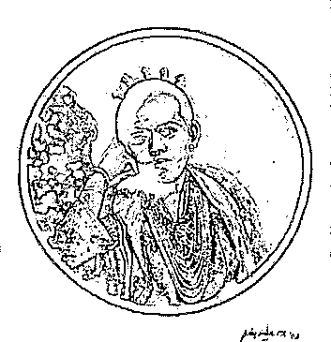

Name of Artist: Redza Piyadasa
Title of Artwork: ________________________________________
Year: 2003
Type of colours used:_______________________

_________________________________________

Neatness in colouring | /1
Correct colours used | /3
Name of Artist | /1
Type of colours used | /1

- end -

